**ACTIVITY 3: ADD SPREADSHEET DATA TO A MAP**

This activity is optional, and can be done during the live demonstration with the facilitator.

1. Download QGIS (https://www.qgis.org/download/)
2. Download the worksheet spreadsheet from google sheets onto your computer as a CSV file. Only download one tab, not the whole spreadsheet with many tabs
3. Open QGIS and create a new blank project 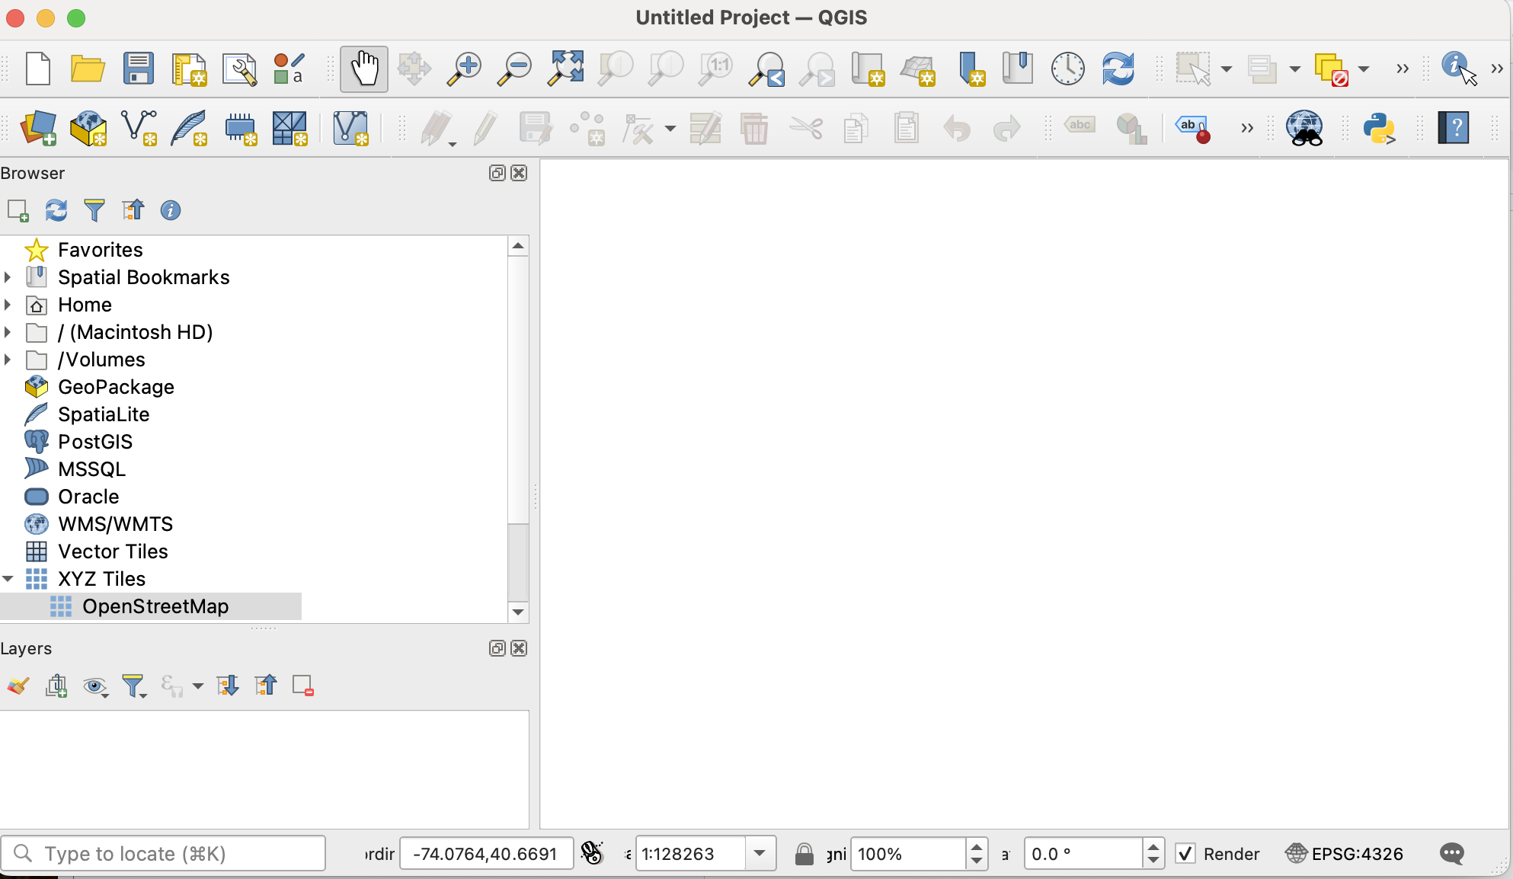
4. Save your project 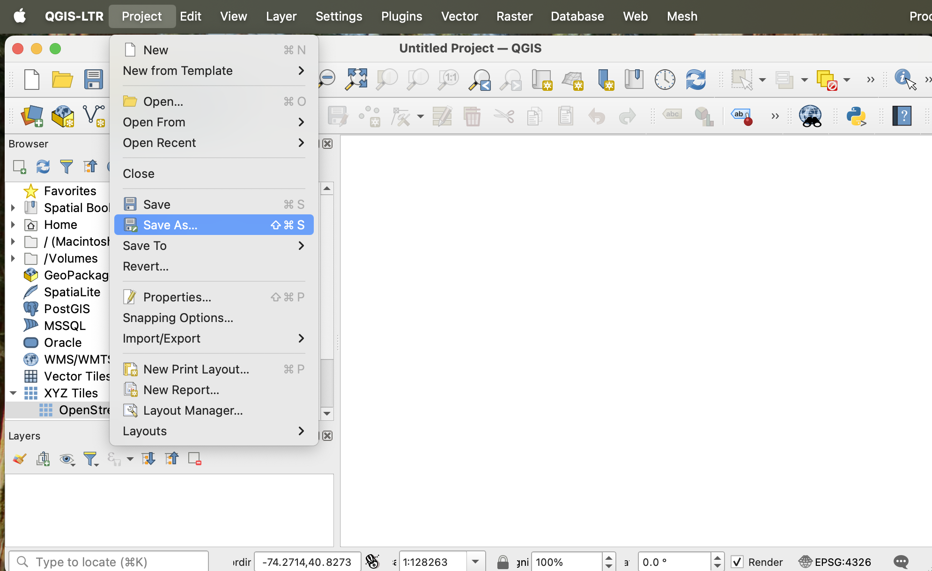
5. Add a streetmap layer by clicking “XYZ TILES” and “Open Street Maps”. Play around with the zooming in and out until you see “Newark” 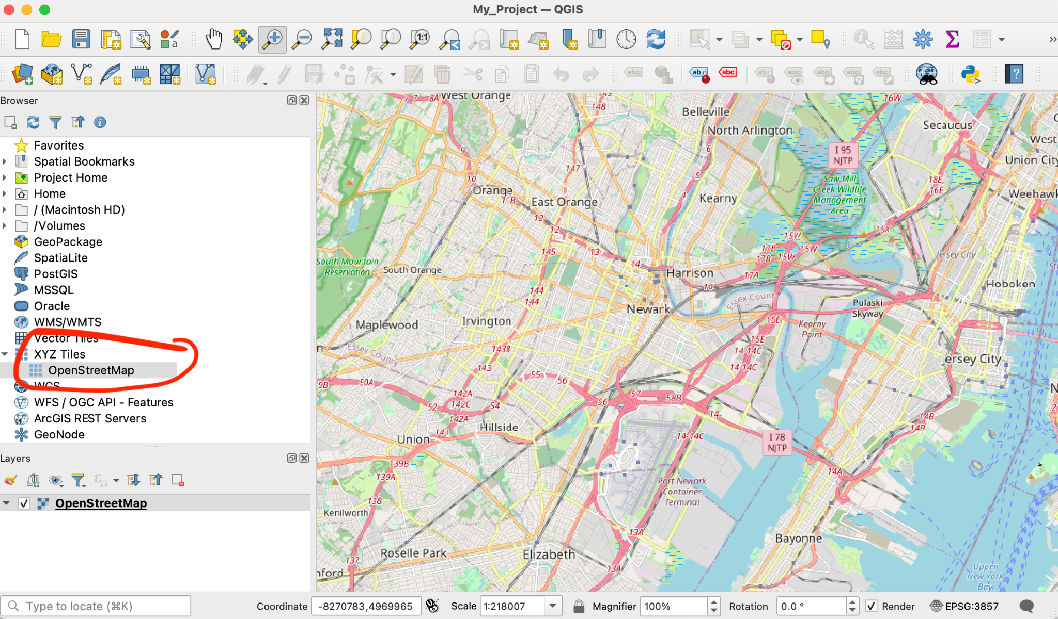
6. Make the map slightly transparent, so it’s easier to plot data on top. Double click “OpenStreetMap” and set transparency to 70%. Click “OK”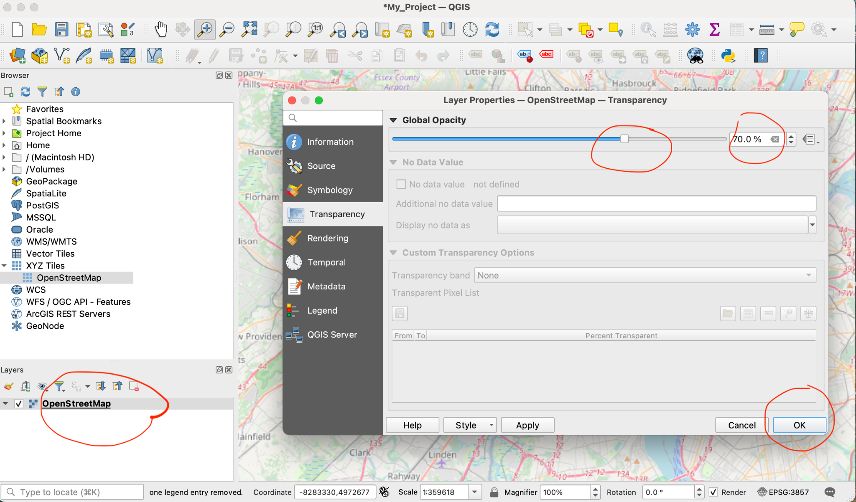
7. Now, you can plot the locations of CBOs, restaurants, and other things in the spreadsheet we were working on during the course. Click the top left button that has a green plus sign, and then click “Delimited Text”. This is how you add a spreadsheet to QGIS. 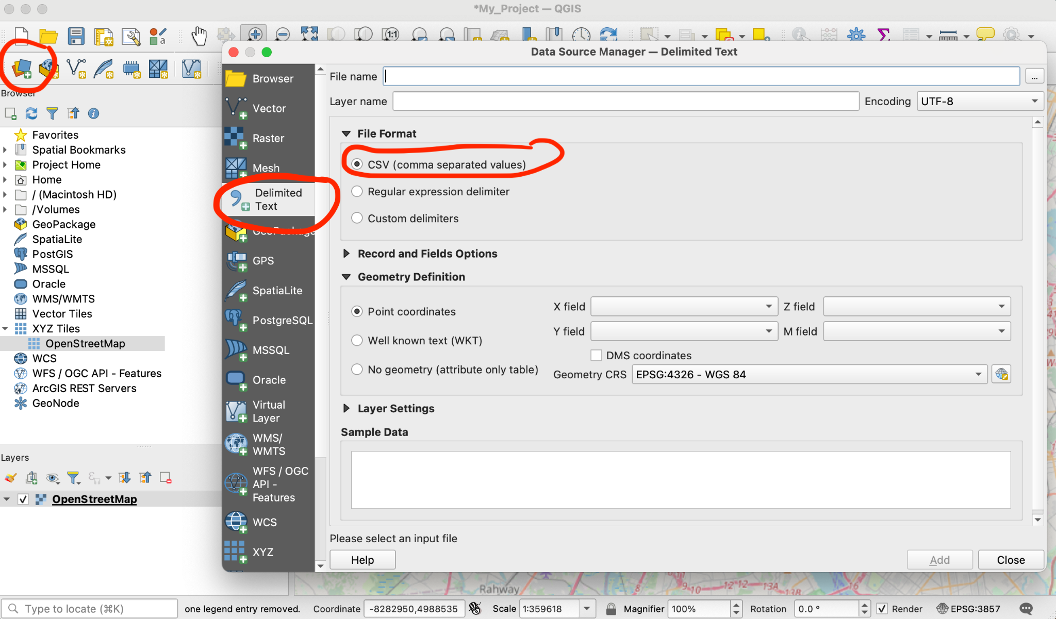
8. Make sure the following parameters are there:
   1. Locate the spreadsheet you downloaded in “File Name”. It is probably in your downloads or desktop.
   2. Make sure to check “CSV”
   3. Make sure X field says “X_coord’ and Y field says “Y_coord”
   4. Make sure the Geometry says “WGS84”
   5. Click “Add

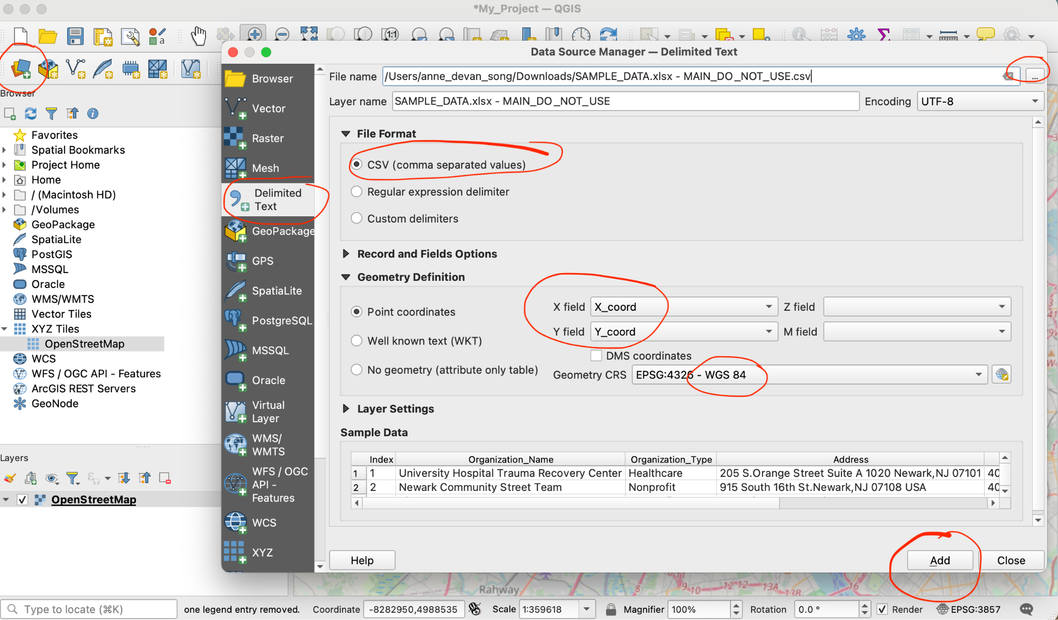

1. You should see small dots around Newark. These are your CBOs, restaurants, etc, that you added to the spreadsheet. They should all be in the vicinity of Newark area. 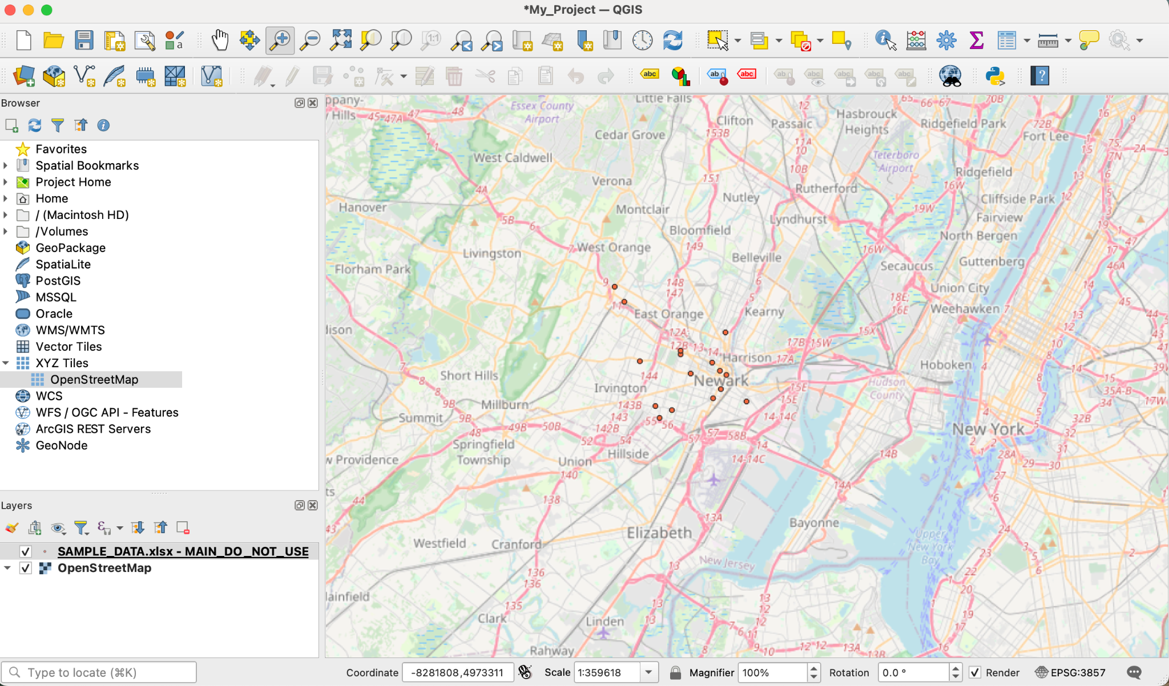
2. Double click on the CSV dataset to change the symbols

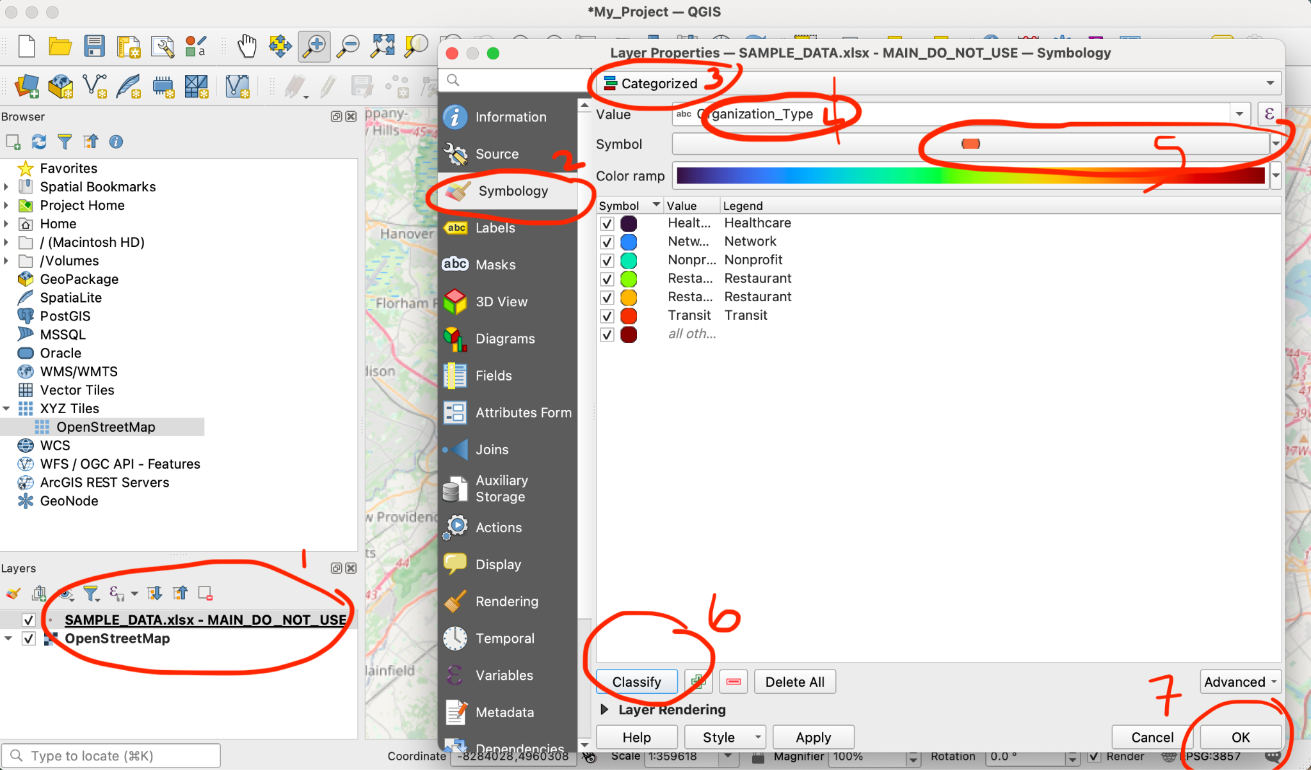

1. Get information from one of the points on the map 